Installing IIS 7 on Windows Server 2008 R2

Before You Begin
Ensure that you have administrative user rights on the computer on which you plan to install IIS 7 or above. Note that by default, you do not have administrative user rights if you are logged on as a user other than as the built-in administrator, even if you were added to the local Administrators group on the computer (this is a new security feature in Windows Server 2008 called Local User Administrator).

Log on either to the built-in administrator account, or explicitly invoke applications as the built-in administrator by using the runas command-line tool.

Note that you can run runas /user:administrator cmd.exe so that every application you run from that command line will be elevated, eliminating the need to use the runas syntax from that command line.

If you are logged on to an account other than the built-in local administrator account, you may see the following security alert dialog box.

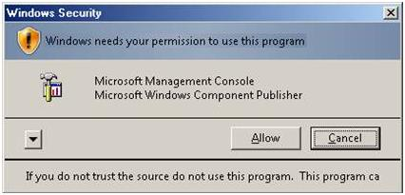
Windows Security (User Account Control)

Install IIS 7.5 on Windows Server 2008 R2
IIS is one of the Windows Server server roles. IIS can be installed through the graphical user interface (GUI) by using the new Server Manager interface after the Windows Server operating system is installed.

Server Manager provides a single dashboard to install or uninstall server roles and features. Server Manager also gives an overview of all currently installed roles and features. When IIS is chosen from the Server Manager, the basic components and services needed for IIS are automatically selected.

1. Click Start -> All Programs -> Administrative Tools -> Server Manager.

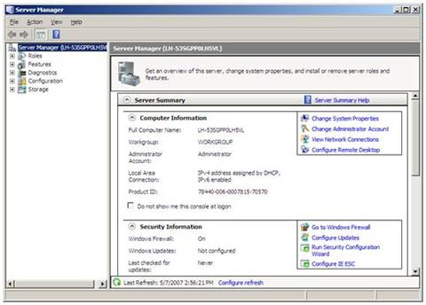
Server Manager

2. In the Server Manager window, scroll down to Roles Summary, and then click Add Roles. The Add Roles Wizard will start with a Before You Begin page. The wizard asks for verification of the following:
a. The administrator account has a strong password.
b. The network settings, such as IP addresses, are configured.
c. The latest security updates from Windows Update are installed.

3. Select Web Server (IIS) on the Select Server Roles page. An introductory page will open with links for further information.

Note: When you use the Add Roles Wizard to install IIS, you get the default installation, which has a minimum set of role services. If you need additional IIS role services, such as Application Development or Health and Diagnostics, make sure to select the check boxes associated with those features in the Select Role Services page of the wizard.

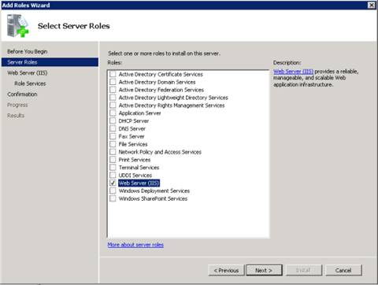
Select Server Roles

4. On the Select Role Services page, select the check box for ASP.NET

Make sure that the following role services are selected:
  - Static Content
  - Default Document
  - Directory Browsing
  - HTTP Errors
Click Next to continue.

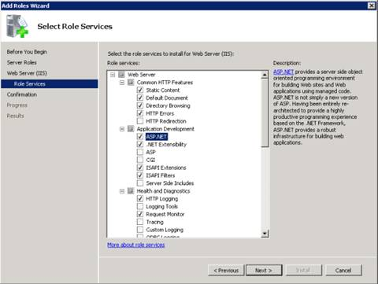
Select Role Services

5. Add any required role services.

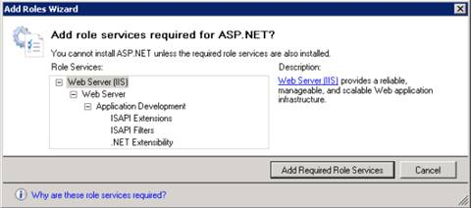
Wizard warning page

6. IIS is now installed with a default configuration for hosting ASP.NET on Windows Server. Click Close to complete the process.

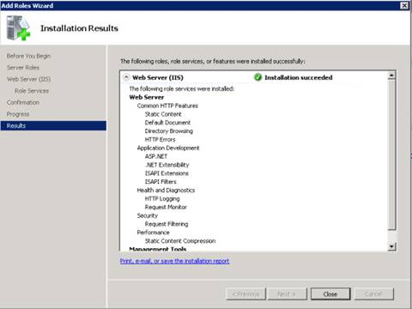
Installation Results page

7. Confirm that the Web server works by using http://localhost.

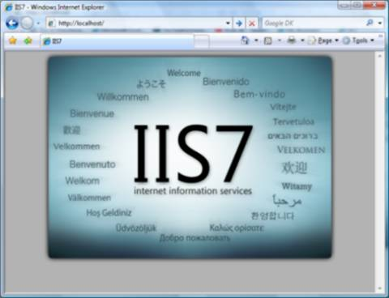

Default Web site

